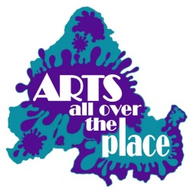
The writing On The Wall
Arts All Over The Place festival 2019 poetry submission.
Please e mail your poem, preferably in WORD, to artsallovertheplace@yahoo.co.uk before October 1st 2019
They can be on any subject, the theme for National Poetry day (October 4th) in 2019 is TRUTH, and we will be celebrating this day with several events. We also especially like poems about the locality of Digbeth for the poetry trail.
Poems must be your own work and not previously submitted to AAOTP.
We prefer poems to fit on one A4 side in font size 12. We will endeavour to keep your layout.
Due to printing costs etc we can only accept words and not images, and can only print in black and white. Please do not include a background colour.
Each person may submit up to 6 poems per year. For printing purposes you may include your name, a pseudonym, or put ‘anonymous’. ( but we need to know who it has come from!)
All exhibitors must be a member of Arts All Over The Place registered charity CIO, it is free to join. You should preferably live in the UK Midlands, and have connections with the Mental Health community. A membership form can be found on our website artsallovertheplace.org.uk.
We will have poems displayed during the festival from Oct 3rd to 10th October ( see festival brochure for details) We will print a selection of poems for display and may use some lines on the poetry trail , with poems displayed on lampposts etc to show the way, raise awareness etc.
Poems will be collected in a booklet at a later date which will be sold to cover costs. Poets get a free booklet each.
Poems will be added to our website: artsallovertheplace.org.uk

